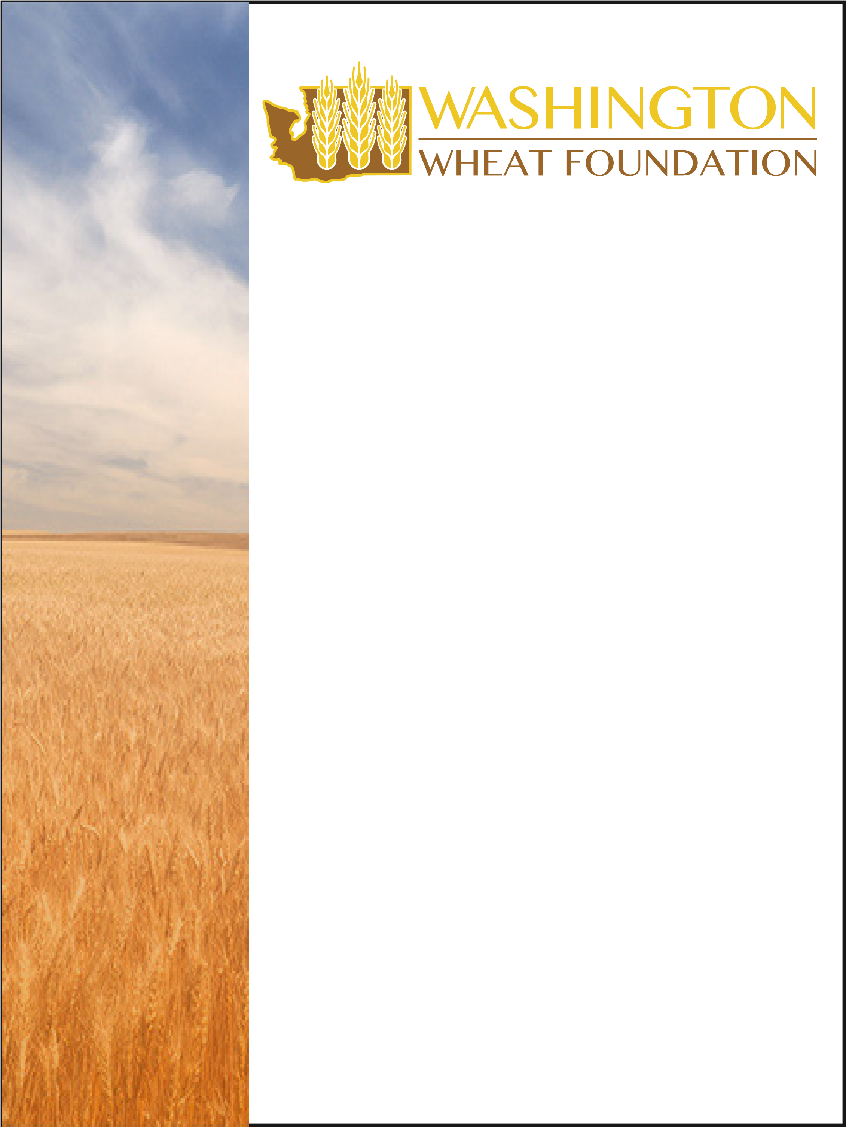

Auction Donations
For years, the Washington Wheat Foundation Auction has been a highlight of our convention. Proceeds from the Auction benefit our Washington ag industry. From research equipment to scholarships, the Washington Wheat Foundation supports various activities making a positive influence on farming including:
• Public Information (through WAWG)
- Research Equipment Grants
- Washington Association of Wheat Growers
- Scholarships (Two $1500 scholarships are awarded each fall to WSU)
- Educational Grants that Support the Consumer & Youth Education
The Auction will be held at the convention’s evening banquet on Thursday, December 2, 2021, at The Davenport Grand Hotel.
If you and/or your company would like to make a charitable contribution to the 2021 Washington Wheat Foundation Auction, please fill out the form below and fax it to the WAWG office at 509-659-4302, or mail it to 109 E. First Ave., Ritzville, WA 99169. If you have questions, feel free to contact Walt Neff at 509-544-9099 and neffrnch@bossig.com OR Kate Malone at 509-710-3559 and washingtonwheatfoundation@gmail.com.
Company Name____________________________________________
Contact Name_____________________________________________
Phone______________________________________________________
Description of Donated Item(s)______________________________
___________________________________________________________
___________________________________________________________
Market Value of Donated Item_______________________________

